**Body Boost**

|  |
| --- |
| **Riphah** |

**By:**

**Anosh Junaid**

**11359**

**Muhammad Ali Hamza**

**12826**

**Hidayat Ullah**

**11939**

**Supervised by:**

**Mr. Muhammad Usman Karim**

**Faculty of Computing**

**Riphah International University, Islamabad**

**Spring/Fall 2023**

**A Dissertation Submitted To**

**Faculty of Computing,**

**Riphah International University, Islamabad**

**As a Partial Fulfillment of the Requirement for the Award of the Degree of**

**Bachelors of Science in Software Engineering**

**Faculty of Computing**

**Riphah International University, Islamabad**

Date: [12, Jan 2024]

**Final Approval**

This is to certify that we have read the report submitted by **Anosh Junaid (Sap Id #11359)**, **Muhammad Ali Hamza (Sap Id #12826), Hidayat Ullah (Sap Id #11939)** for the partial fulfillment of the requirements for the degree of the Bachelor’s of Science in Computer Science (BSCS). It is our judgment that this report is of sufficient standard to warrant its acceptance by Riphah International University, Islamabad for the degree of Bachelor’s of Science in Computer Science (BSCS).

**Committee:**

|  |  |
| --- | --- |
| **1** | [Name Supervisor]  (Mr. Muhammad Usman Karim) |
|  |  |
| **2** | [DR. Musharaf Ahmed]  (Head of Department/chairman) |

**Declaration**

We hereby declare that this document “**BodyBoost**” neither as a whole nor as a part has been copied out from any source. It is further declared that we have done this project with the accompanied report entirely on the basis of our personal efforts, under the proficient guidance of our teachers especially our supervisor **Mr. Muhammad Usman Karim**. If any part of the system is proved to be copied out from any source or found to be reproduction of any project from anywhere else, we shall stand by the consequences.

**___________________________**

**Anosh Junaid**

**11359**

**___________________________**

**Muhammad Ali Hamza**

**12826**

**___________________________**

**Hidayat Ullah**

**11939**

**Dedication**

To the kindest person, Mother, and especially the dearest person, Father who was always our support and whose prayers brought us up to this level and our supervisor; the kindest dedicated person that it would have been impossible for us to complete or accomplish our goals of the project if he wasn’t there for us.

**Acknowledgement**

First of all, we are obliged to Allah Almighty the Merciful, the Beneficent and the source of all Knowledge, for granting us the courage and knowledge to complete this Project. We want to express our sincere thanks to our project supervisor **Mr. Muhammad Usman Karim** for his guidance. We also take this opportunity to thank our parents for the unceasing encouragement, support, attention and reassuring our confidence. We also place our sense of gratitude on record to one and all who directly or indirectly have lent their hand in this venture. Lastly, we would like to thank each other (Project Team – Anosh Junaid, Muhammad Ali Hamza and Hidayat Ullah) for caring support under challenging situations.

**___________________________**

**Anosh Junaid**

**11359**

**___________________________**

**Muhammad Ali Hamza**

**12826**

**___________________________**

**Hidayat Ullah**

**11939**

**Abstract**

The global health and fitness industry is continuously growing, with an increasing number of people looking for convenient ways to stay fit and healthy. After COVID 19

People become app oriented, they don’t want to go in gym rather they want to do exercises in home on their free time. They want to have good diet plan and do proper exercise to keep themselves fit, Problem occurs when some people who aren’t mentally stable or in stress when they start eating nutrients what aren’t good for their health. Our app can tap into this expanding market Provide users with personalized workout and diet plans tailored to their emotional states, contributing to holistic well-being. By integrating social media textual data, the system captures real-time sentiments, enabling personalized workout and diet plans aligned with users' emotional states expressed.

**Table of Contents**

Chapter 1 2

INTRODUCTION 2

1.1 Introduction 2

A. Opportunity and Stakeholder 2

1.2.1 Health and Fitness Industry Growth 3

1.2.2 Stakeholders 3

B. Motives and Challenges 3

C. Goals and Objectives 4

D. Solution Overview 4

E. Report Outline 5

V. Chapter 2 6

2 LITERATURE/MARKET SURVEY 6

2.1 Introduction 6

A. Background and Problem Elaboration 6

B. Detailed Literature Reviewer 7

2.2.2 Existing Solutions for BodyBoost 7

2.2.3 Strengths: 7

2.2.4 Weaknesses: 7

2.2.5 Related research work 8

VI. Chapter 3 11

3 REQUIREMENT ANALYSIS 11

A. Introduction 11

B. Problem Scenario 11

C. Functional Requirements 12

3.1 Non-Functional Requirements 12

D. SQA Activities: Defect Detection 13

3.1.3 Test case design: 13

VII. Chapter 4 15

4 SYSTEM DESIGN 15

4.1 Introduction 15

4.2 Test case Design and description 15

4.2.1 Test Case Number 1 15

4.3 Architectural Design 18

4.4 Detailed Design 19

4.4.1 Fully dressed use cases 20

4.5 Methodology 30

VIII. Chapter 5 31

IX. Experimental Results and Analysis 31

**5.1.2** **Team Members** 31

**5.1.3** **Work Breakdown Structure (WBS)** 31

**5.2.1** **Project Schedule** 32

**5.2.2** **Way of Working** 32

**5.2.3** **Risk Management** 32

**5.3** **Flow Control/Pseudo codes** 33

**5.3.1** **Sign up Page** 33

**5.3.2** **Login Page** 33

**5.4** **Components, Libraries, Web Services, and Stubs** 34

**5.4.1** **Components** 34

**5.4.2** **Libraries** 35

**5.4.3** **Web Services** 35

**5.4.3** **Stubs** 37

**5.5** **IDE, Tools and Technologies** 37

**5.6** **Best Practices and Coding Standards** 37

**5.7** **Deployment Environment for Body Boost** 38

**5.8** **Summary** 38

Chapter 6 39

Conclusion and Future Directions 39

6.1 Conclusion: 39

6.2 Future Directions: 39

6.3 Recommendations for future work: 39

X. Bibliography 40

**List of Figures**

Figure ‎4.1 Architectural Design 16

Figure ‎4.2 Use Case Diagram 17

Figure ‎4.3:- Methodology Diagram 28

Figure 5.1 Testing twitter API in Post Man 34

Figure 5.2 shows that we are unable to enter twitter URL 34

**List of Tables**

Table ‎2.1 Summary table of research paper 9

Table ‎4.1 Register 18

Table ‎4.2 login 19

Table ‎4.3 View profile 20

Table ‎4.4 Manage Profile 21

Table ‎4.5 Manage users 21

Table ‎4.6 Mange Exercise 22

Table ‎4.7 Exercise 23

Table ‎4.8 View workout schedule 23

Table ‎4.9 Create diet plan 24

Table ‎4.10 Track progress 25

Table ‎4.11 Notification 26

Table ‎4.12 Feedback 26

Chapter 1

INTRODUCTION

# Introduction

Physical activity can help people maintain a healthy weight and lower their chance of developing a variety of chronic conditions and many diseases. Despite this information, adults and children in many nations, countries do not engage in physical activity on a regular basis or any physical games. Researchers have never-before-seen chances to learn and adopt more about the health advantages of physical activity thanks to recent advancements in physical activity monitoring

## Opportunity and Stakeholder

Research indicates that technology has played a role in the rise in sitting down and decline in physical activity. On the other hand, it has additionally inspired a number of creative physical activity-focused therapies. One such innovation is through the use of mobile fitness apps and the sharing of one’s workout through a social network. This paper will focus on the collection of self-reported fitness data through a mobile fitness app that is then shared with one’s social network via Twitter. The dataset of these tweets along with other connected datasets of demographic information allows for a number of analyses, including but not limited to the potential influence of such tweets and the sentiment of these tweets. By combining the digital traces as people interact through mobile phones and emerging technology may now provide novel methods to assess a range of factors objectively and with minimal expense and burden to participants. This paper will review both the potential online influence and the sentiment of the shared fitness tweets.

The way societies have been exposed to information has changed as a result of social media like Facebook, tweeter etc. Twitter has developed into a more beneficial tool for the general population to express their opinions, ideas, and thoughts. Twitter is one of the most used applications worldwide. It is a free social networking site that is utilized by both people and companies to share their ideas and business.

The mission of Twitter is to “give everyone the power to create and share ideas and information instantly, without barriers”. With 328 million active monthly users, more than 1 billion unique visitors each month to sites with embedded tweets. Twitter users can rapidly and directly share with and respond to a massive audience, using messages of 140 characters or less. With the creation and introduction of newly developing technologies such as Twitter, new opportunities to obtain global health data that may circumvent the limitations of traditional data sources used in population health and physical activity research are now available.

1.2.1 Health and Fitness Industry Growth: The global health and fitness industry is continuously growing, with an increasing number of people looking for convenient ways to stay fit and healthy. Our app can tap into this expanding market.

### Stakeholders

#### Fitness Trainers**:** The individuals who will use the app to improve their fitness and overall health.

#### Admin: Admin will manage user, workout, diet plans and checking the effectiveness of sentiment analysis feature app.

## Motives and Challenges

The main motive in our mind is to develop a fitness app so that it will facilitate user and nutritionist both. Our App will provide users with personalized workout and diet plans tailored to their emotional states, contributing to holistic well-being. To give good diet and exercise but looking at his mental state, the detection will be performed using Machine learning models.

In our fast-paced lives, we often struggle to stay healthy while dealing with different emotions like stress or happiness. The problem is current fitness apps don't really understand our feelings. They give us the same exercises and diet plans, no matter how we're feeling. This disconnect means we miss out on personalized advice that matches our emotions. The motivation for a new solution is clear. We need a smart system that understands our feelings in real-time. Using this system, we can create personalized workouts and diets that match our feelings, making it much easier to stay healthy and happy.

## Goals and Objectives

We want to create a smart system that understands how you're feeling, like if you're stressed or happy. Our fitness app's objectives include encouraging overall wellbeing through the integration of sentiment analysis and BMI calculations for an integrated strategy to health. Our goal is to customize fitness experiences by making nutrition and exercise suggestions based on individual body metrics and social media-derived emotional states. Our goals are to: apply precise BMI computations; incorporate a dependable sentiment analysis module; create an adaptive recommendation engine; guarantee user-friendly profile management; give app security and privacy first priority; create mechanisms for continuous improvement; and develop a pleasant and easy-to-use user experience. By implementing these aims and objectives, we hope to provide a motivating and encouraging fitness platform that takes into factors related to mental and physical health and fosters long-term user engagement.

## Solution Overview

Our app can tap into this expanding market Provide users with personalized workout and diet plans tailored to their emotional states, contributing to holistic well-being. By integrating social media textual data, the system captures real-time sentiments, enabling personalized workout and diet plans aligned with users' emotional states expressed.

* 1. **Conclusion**

We want to create a smart system that understands how you're feeling, like if you're stressed or happy. This system will use that info to give you personalized workout and diet plans. It's similar to having a fitness buddy fitness partner. It will be easy to use and understand, so you won't need to be a mobile application expert and genius. Our goal is to help you manage your physical and mental state, deal with your emotions, and find your path to health and fitness. We want to convert the way you manage your health by customizing your fitness journey to fit your specific needs and emotional state. The goal is to grow a happier, healthier version of yourself by making good food and training choices every step of the way.

## Report Outline

Our project involves the implementation of a fitness app through sentiment analysis algorithms. It will process user-input sentiments, extracting emotional cues such as stress or happiness, forming the foundation for personalized recommendations. The Data will be Collected gather from user-input data, which may include text-based input or responses to emotion-related prompts. This could be collected directly within the application or through integrated social media platforms.

# Chapter 2

# LITERATURE/MARKET SURVEY

## Introduction

In this chapter, we have discussed our background and problem elaboration in detail. In detailed literature review, we have mentioned that how previous studies showed that a variety of researchers from across the globe are working on sentimental analysis and health and fitness.

Our focus is around the intersection of emotional assessment, fitness, and nutrition. Through a comprehensive literature review, we find research has been conducted on sentiment analysis in health-related forums and social media platforms. Studies explore how sentiment analysis can be applied to understand user emotions and attitudes towards health issues, the literature on personalized fitness applications has focused on algorithms for tailoring workout plans based on user characteristics such as fitness level, preferences, and goals. [See table 2.1]

Existing fitness applications often provide generic workout and diet plans, lacking the finesse of tailoring recommendations based on users' emotional states. Our research seeks to bridge this gap by integrating sentiment analysis algorithms to discern users' emotional states and preferences, subsequently offering bespoke workout routines and dietary guidance. We have also explained existing apps that can facilitate user regarding their health issues and fitness goals i.e. (Nike training club, My Fitness Pal) and how they work.

## Background and Problem Elaboration

In today's world, lots of people want personalized fitness help from their phones. But the apps we have now mostly miss out on understanding how our feelings affect our health choices. Our project, it wants to create a new kind of app that listens to your emotions and gives you fitness and diet plans that really fit you. With everyone using smartphones, this is the perfect time to make an app that really understands how we feel about our health.

The problem is, the current fitness apps are a bit basic. They give everyone the same exercises and diets, ignoring that we all feel different. This one-size-fits-all method doesn’t work for everyone. Our research shows that there's no app that truly gets how person feelings, our ups and downs, affect our health choices. We want to make an app that not only knows the exercises and foods you need but also understands how you feel, making your health journey more personal and enjoyable. The app which uses social media post like tweets to detect mental state. Through our project, we aim to fill this gap and make a fitness and nutrition app that's as unique as you are.

## Detailed Literature Reviewer

Previous studies showed that a variety of researchers from across the globe are working on sentimental analysis, health and fitness but very little work has been done on fitness app which takes user mental health and suggest workout plan and diet.

### ****Existing Solutions for BodyBoost****

Several existing mobile applications and platforms address the needs of fitness ……apps. Some notable examples include:

#### ****Fitbit:**** Offers activity tracking and give exercise and calculate the mass of our body.

#### ****MyFitnessPal**:** Provides a similar service with comprehensive meal tracking and dedicated workout.

#### ****Nike Training Club**: Gives customized workout plans**.

#### ****7 Minute Workout**:** Gives a quick and focused workout.

### ****Strengths****:

* These application gives a wide range of trackers that monitors various activities.
* Some of the apps provides valuable insights into user and helping them make informed choices.
* App often include variety of workouts and catering to different fitness level.

### ****Weaknesses****:

* Users find this app difficult to use, especially new member.
* Some advance features behind a premium feature, which may deter budget conscious user.
* Lack of information of the user mental health led it to the lack of wellbeing of the user.

### Related research work

Previous studies showed that a variety of researchers from across the globe are working on sentimental analysis, health and fitness but very little work has been done on fitness app which takes user mental health and suggest workout plan and diet.

[1] Facebook Al developed RoBERTa (short for “Robustly Optimized BERT Approach”) which is the variant of BERT (Bidirectional Encoder Representations from Transformers) model. it is transformer-based language model. In BERT, the system learns by predicting intentionally hidden parts of sentences in unannotated language examples. There was two key change in Roberta. It removes BERT's next-sentence pretraining objective (NSP). And RoBERTa was trained on a much larger dataset.

The training data includes existing unannotated NLP datasets and a new set called CC-News, derived from public news articles. The model achieves an overall score of 88.5 on the GLUE benchmark, which stands for General Language Understanding Evaluation. This benchmark consists of multiple NLP tasks. The GLUE leaderboard refers to the ranking system for models participating in the General Language Understanding Evaluation (GLUE) benchmark. It is designed to evaluate the general language understanding capabilities of models. We also match state-of-the-art results on SQuAD. SQuAD stands for the "Stanford Question Answering Dataset." SQuAD is designed to evaluate the ability of computer systems to understand and answer questions posed by humans based on a given passage of text.

[2] Sunir Gohil, Sabine Vuik and Ara Darzi paper sets out with the primary objective of understanding the tools available for sentiment analysis in health care research on Twitter. The second objective was to determine which method would work best in the health care settings, by analyzing how the methods were used to answer specific health care questions, their production, and how their accuracy was analyzed. The study found that people use different methods to figure out the feelings in tweets, from simple ways to expensive tools. It says we need better tools that are trained specifically on health-related tweets. The study looked at 12 papers published between 2011 and 2016, and in about 46% of health tweets, people express either positive or negative feelings. The researchers suggest that it's crucial to have accurate tools that understand the unique way people talk about health on Twitter.

[3] Muhammet Sinan Başarslan, Fatih Kayaalp This study explores how social media, particularly Twitter, is a significant part of our daily lives. The research specifically investigates how different ways of representing text affect the accuracy of sentiment analysis. Two datasets were used of 4500 Twitter records of IMDB Movies & health-related twitter data one with user reviews about movies from IMDB and another with Twitter tweets about health in English from 2019. The study implemented classification models using Naïve Bayes, Support Vector Machines, and Artificial Neural Networks in Python. The results showed that Artificial Neural Networks performed the best in terms of accuracy for both datasets with score of 0.85. The NB gave the worst performance among others in both datasets.

Table ‎2.1 Summary table of research paper

|  |  |  |  |  |  |  |
| --- | --- | --- | --- | --- | --- | --- |
| No. | Author Name | Language | Year | Methods | Data Description | Performance |
| 1. | Facebook  AL & | English | 2019 | RoBERTa and BERT | 160GB of  text | SQuAD 94.6/89.4  88.5 on the GLUE benchmark |
| 2. | Sunir  Gohil,  Sabine  Vuik and  Ara Darzi | English | 2018 | SVM ,  SVM, NB & k-NN | 12 papers were compared | 46% (92/2) of health-based tweets contain some form of positive or negative sentiment. |
| 3. | Muhammet  Sinan  Başarslan,  Fatih  Kayaalp | English | 2020 | NB, SVM &  ANN | 4500 Twitter records of IMDB Movies & health-related twitter data | 0.85 Accuracy |

* 1. **Summary**

In this chapter we gathered various research paper related to sentimental analysis which uses machine learning and have a different accuracy rate. Roberto model have excellent accuracy and wide range of different feature like hate speech detection, irony detection which can be very helpful for sentimental analysis. We also discussed different apps which have different strength and weakness. Every app has different purpose like 7 Minute Workout have only quick work out and have no feature for diet plan or sentimental analysis. We have also discussed there is increase in demand of personalized fitness assistance since Covid. Existing apps does not have option for understanding the emotional aspect of health. This application aims to fill this gap by creating an app that considers user emotions by using textual data and provides custom work out and diet plans.

# Chapter 3

# REQUIREMENT ANALYSIS

## 3.1 Introduction

In this chapter we have developed our functional requirements for our actors i.e. (user, admin). We have also developed functional requirements here we discuss those factors which may not be direct features of our designed system but are important to consider during our system’s development. We purposed our methodology in which we aim to develop a fitness app that will facilitate the user, main motive in our mind is to develop a fitness app so that it will facilitate user and nutritionist both. Our App will provide users with personalized workout and diet plans tailored to their emotional states, contributing to holistic well-being. To give good diet and exercise but looking at his mental state, the detection will be performed using Machine learning models.

## Problem Scenario

**3.2.1 Context:**

In a fitness world people are often face challenges that an app should not only addresses physical health but emotional health too. there's a growing need for a fitness app that provides personalized workout routines and diet plans and also integrates emotional well-being.

**3.2.2 Problem:**

Due to limited emotional support many fitness apps mainly focus on physical exercises and diet plan but lack features addressing user’s emotional state. Users might feel a gap in the support provided, especially during challenging times after covid.

Maintaining consistent user interaction can be a difficult task for fitness apps. Users may lose interest or motivation over time due to workout provided was not according to their state of mind. Exercises and diet plan cannot be same for depress person and active person which leading to reduced app utilization and potentially hindering their fitness progress.

**3.2.3 Goals:**

The primary goal is to create a fitness app that continuously integrates physical and emotional well-being every day. This includes providing workout routines and diet plans a which are designed according to the emotional state of the person that are on users' social media sentiment analysis.

To enhanced user engagement, we are offering customizable workout plans, diet recommendations, and emotional support features. which uses your social media post, or captions to check sentimental analysis. Social media is place where people express themselves. it can be good source for user emotions detection. If users show signs of stress or low mood, provide appropriate exercise recommendations to help ease stress and enhance their emotional well-being.

## Functional Requirements

User Table 3.1

|  |  |
| --- | --- |
| **ID** | **Requirements** |
| FR 1.1 | User shall be able to register an account. |
| FR 1.2 | User shall be able to login to their account. |
| FR 1.3 | User shall be able to view and edit his profile. |
| FR 1.4 | User shall be able to do sentimental analysis. |
| FR 1.5 | User shall be able to track progress. |
| FR 1.6 | User shall be able to access exercises. |
| FR 1.7 | User shall be able to calculate BMI. |
| FR 1.8 | User shall be able to access diet plan. |
| FR 1.9 | User shall be able to view his schedule. |
| FR 2.0 | User shall be able to give feedback. |

Admin Table 3.2

|  |  |
| --- | --- |
| **ID** | **Requirements** |
| FR 3.1 | Admin shall be able to login to their account. |
| FR 3.2 | Admin shall be able to view and edit his profile. |
| FR 3.3 | Admin shall be able manage users. |
| FR 3.4 | Admin shall be able to manage diet plan. |
| FR 3.5 | Admin shall be able to track progress of users. |
| FR 3.6 | Admin shall be able to manage all workouts. |
| FR 3.7 | Admin shall be able to manage Notification. |

### Non-Functional Requirements

Non-functional requirements are the capabilities, constraints and specifications which help enhance the system and its usage. Unlike functional requirements here we discuss those factors which may not be direct features of our designed system but are important to consider during our system’s development.

* + 1. Accuracy: The system should be accurately the mood sentiments.
    2. Speed: The system should process data in real-time to quickly detect mood of the user.

## SQA Activities: Defect Detection

Software Quality Assurance (SQA) ensures the app and website meet defined requirements. This includes various defect detection activities:

### Test case design:

|  |  |
| --- | --- |
| **Test Data** | TD-1 |
| **Form** | Login |
| **Stakeholder** | User |
| **Field** | Email |
| **Technique** | Equivalence Partitioning |
| **Valid** | * Correct length * No Space or Special Character |
| **Invalid** | * Not contain '@' * Includes special characters |

|  |  |
| --- | --- |
| **Test Data** | TD-1 |
| **Form** | Login |
| **Stakeholder** | User |
| **Field** | Password |
| **Technique** | Equivalence Partitioning |
| **Valid** | * Password Length should be >=6 * Includes special characters * Includes one numeric character |
| **Invalid** | * Password length < 6 * No special character * No numeric character |

|  |  |
| --- | --- |
| **Test Data** | TD-2 |
| **Form** | Sentimental analysis |
| **Stakeholder** | User |
| **Field** | Enter your last tweet /caption |
| **Technique** | Equivalence Partitioning |
| **Valid** | * Input length should be >=5 * Input length should be <50 |
| **Invalid** | * Contain “http” * Contain @user * Special character |

# Chapter 4

# SYSTEM DESIGN

## Introduction

In this chapter, we aim to present a comprehensive collection of design diagrams, including architectural, use case and activity designs for our project "BodyBoost." Through these diagrams, our goal is to represent visually, both the system's workflow and its technical design.

## **Test case Design and description**

## **Test Case Number 1**

|  |  |  |  |  |  |
| --- | --- | --- | --- | --- | --- |
| **BodyBoost** | | | | | |
| **Reference=**N/A | | | | | |
| Test Case ID: | | 001 | Test Date: | | 28-04-2024 |
| Test case Version: | | Register-TC-1.0 | Use Case Reference(s): | | UC-Register-001 |
| Revision History: | | Nill | | | |
| Objective | | To verify that the registration process on the platform is working accurately and permit users to create new accounts successfully. | | | |
| Product/Ver/Module: | | . Nill | | | |
| Environment: | | It should have the necessary software requirements for the platform to run smoothly | | | |
| Assumptions: | | * The platform has been completed thoroughly, tested, and is steady. * The platform provides the necessary user interface and functionality for user registration. | | | |
| Pre-Requisite: | | * The registration system works properly and is usable by users. * The user's email address is active and usable for registration purposes. * The user hasn't signed up for the platform before | | | |
| Step No. | Execution description | | | Procedure result | |
|  | * All required fields, including username, email address, and password, are filled out with accurate and distinct information. * The registration form is submitted by clicking the "Register" or "Sign Up" button. * A success message or confirmation stating that the registration was successful is returned by the system. | | | * If every step is followed exactly as directed and the registration is finished without any mistakes, the outcome gets recorded as "Registration successful." * If there are any problems with any of the steps, the result is marked as "Registration unsuccessful" or "Registration failed," and the particular problem is highlighted. | |
| Comments:   * To assure proper error handling and user feedback, it is recommended to test the registration process with various scenarios, including invalid inputs. * To ensure reliability and consistent behavior, the registration process needs to be tested across a variety of browsers and devices. | | | | | |

* + 1. **Test Case Number 2**

|  |  |  |  |  |  |
| --- | --- | --- | --- | --- | --- |
| **BodyBoost** | | | | | |
| **Reference=**N/A | | | | | |
| Test Case ID: | | 001 | Test Date: | | 28_04_2024 |
| Test case Version: | | Login-TC-2.0 | Use Case Reference(s): | | UC-Login-002 |
| Revision History: | | Nill | | | |
| Objective | | To ensure that users can access the system using correct credentials and log in successfully. | | | |
| Product/Ver/Module: | | Nill | | | |
| Environment: | | App-based platform | | | |
| Assumptions: | | * The login option has been put in place and is working. * The user's username and password must be correct. * The database securely stores the login information. | | | |
| Pre-Requisite: | | * The platform is accessible. * The user is logged in with valid credentials from a registered account. | | | |
| Step No. | Execution description | | | Expected result | |
|  | * The login feature has been appropriately integrated and is prepared for testing, according to the test case. * To properly log in, the user must have a working username and password. * The test assumes that the login information is safely saved in the database and that the system can verify it. | | | * There should be no issues with the login page loading. * The username and password fields should be working and accessible. * There should be a clickable button for login. * The system should check the credentials after the user clicks the login button and then continue to log the user in. * The user should be sent to the relevant page after successfully logging in. * The personal data of the user should be appropriately shown. * The user should be successfully logged out after logging out, and all session or cookie data should be erased. | |
| Comments:   * To properly log in, the user must have a working username and password | | | | | |

## Architectural Design

The architectural design incorporates distinct use cases for both users and administrators in our fitness app. (See figure 4.1) Users can register, log in securely, access personalized exercise and diet plans, and utilize features like BMI. For detailed design (See figure 4.2). Administrators, on the other hand, have functionalities for secure login, user management, and oversight of exercise and diet plan databases, along with the crucial task of system monitoring for optimal performance and security. This ensures a well-defined and secure interaction between users and administrators within the app's framework. For detailed design (See figure 4.3)

**Figure ‎4.1 Architectural Design**

## Detailed Design

* **Trainee**

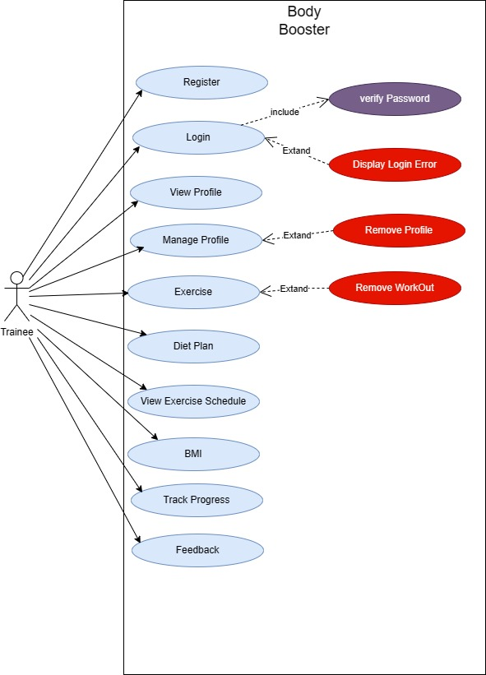

**Figure ‎4.2 Use Case Diagram**

* **Admin**

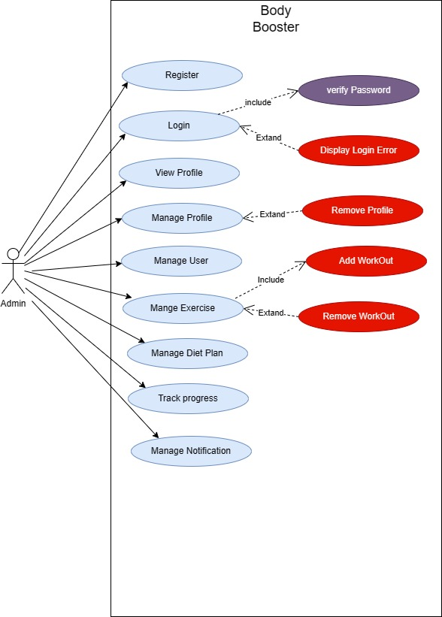

Use Case Diagram of Admin 4.3

### Fully dressed use cases

Table ‎4.1 Register

|  |  |  |  |  |
| --- | --- | --- | --- | --- |
| ID | | UC-001 | | |
| Name | | Register | | |
| Actors | | Admin, Trainee | | |
| Summary | | The actor shall provide their email and password on the registration form and after successful verification, redirect now the user to the login page. | | |
| Pre-Conditions | | Actor must have access to register form | | |
| Post-Conditions | | Actor has successfully registered an account | | |
| Special Requirements | | None | | |
| Basic Flow | | | | |
| Actor Action | | | **System Response** | |
| 1 | Actor enters name, email, and password, information on registration form | | 3 | System displays success  Message if everything goes accordingly |
| 2 | Actor clicks on the submit  Button | | 4 | System saves signup information under a new Account Id |
| **Alternative Flow** | | | | |
| 6 | Email already exists. | | 7 | System displays an error message |
|  |  | | 8 | System restarts use case from step 1 |

Table ‎4.2 login

|  |  |  |  |  |
| --- | --- | --- | --- | --- |
| ID | | UC-002 | | |
| Name | | Login | | |
| Actors | | Admin, Trainee | | |
| Summary | | The actor shall provide their email and password on the login form and after successful verification, redirect the user to the home page. | | |
| Pre-Conditions | | Actor has already registered an account  Actor must have access to the login forum | | |
| Post-Conditions | | Actor has successfully logged into their account. | | |
| Special Requirements | | None | | |
| Basic Flow | | | | |
| Actor Action | | | **System Response** | |
| 1 | Actor enters email and password. | |  |  |
| 2 | Actor clicks on the submit  Button. | | 3 | System verifies credentials. |
|  |  | | 4 | System displays the home page. |
|  |  | | 5 | System gives access to page to main page, exercise, diet plan, running, feedback. |
|  |  | | 6 | System gives access to profile page if he/she is a user or give access to admin dashboard too if he/she is admin |
| **Alternative Flow** | | | | |
| 7 | Actor ends login session | | 8 | System displays an error message |
|  |  | | 9 | System restarts use case from step 1 |

Table ‎4.3 View profile

|  |  |  |  |  |
| --- | --- | --- | --- | --- |
| ID | | UC-003 | | |
| Name | | View Profile | | |
| Actors | | Admin, Trainee | | |
| Summary | | Actor select view profile, system displays view posts section  actor click on profile; system displays a profile | | |
| Pre-Conditions | | Actor must be logged in  Actor must select view profile section | | |
| Post-Conditions | | Actor has viewed profile | | |
| Special Requirements | | None | | |
| Basic Flow | | | | |
| Actor Action | | | **System Response** | |
| 1 | Actor selects view profile | | 2 | System displays view profile section |
| 3 | Actor click on the profile | | 4 | System displays profile |
| **Alternative Flow** | | | | |
| 5 | System displays an error | |  | Not displayed if network error |

Table ‎4.4 Manage Profile

|  |  |  |  |  |
| --- | --- | --- | --- | --- |
| ID | | UC-004 | | |
| Name | | Manage Profile | | |
| Actors | | Trainee, Admin | | |
| Summary | | The user updates their profile information. | | |
| Pre-Conditions | | The user is logged into the platform | | |
| Post-Conditions | | The user's profile information is updated with the changes. | | |
| Special Requirements | | None | | |
| Basic Flow | | | | |
| Actor Action | | | **System Response** | |
| 1 | The user clicks on the "Edit Profile" button. | | 2 | The system displays the editable profile form with the user's current information |
| 3 | The user modifies the desired information on the form | | 4 | The system validates the input and updates the user's profile with the changes. |
| **Alternative Flow** | | | | |
| 5 | System displays an error | |  | Not redirected if network error |

Table ‎4.5 Manage users

|  |  |  |  |  |
| --- | --- | --- | --- | --- |
| ID | | UC-005 | | |
| Name | | Manage Users | | |
| Actors | | Admin | | |
| Summary | | The admin selects, system displays a Manage Users section  Admin selects Add and delete Users, and system will save changes accordingly. | | |
| Pre-Conditions | | Admin must be logged in  Admin must be in Manage Users section | | |
| Post-Conditions | | Admin has managed (Add and delete) Users | | |
| Special Requirements | | None | | |
| Basic Flow | | | | |
| Actor Action | | | **System Response** | |
| 1 | Admin selects Manage Users. | | 2 | System displays the manage (Add and delete) Manage Users section. |
| 3 | Admin selects Add Users  Admin selects delete Users | | 4 | System will save changes accordingly. |
|  |  | | 5 | System will remove the User from database if Admin selects delete User |
| 6 | Admin clicks on submit button | |  |  |
| **Alternative Flow** | | | | |
| 7 | Error will display while adding and deleting User | | 8 | Not edit ((Add and delete) if network error |

Table ‎4.6 Mange Exercise

|  |  |  |  |  |
| --- | --- | --- | --- | --- |
| ID | | UC-006 | | |
| Name | | Manage Exercise | | |
| Actors | | Admin | | |
| Summary | | The actor selects Exercise in home page, system display Exercise section Actor edit exercise. If exercise is valid system saves it in DB and displays in specific section | | |
| Pre-Conditions | | Admin must be logged in | | |
| Post-Conditions | | Admin has edited exercise | | |
| Special Requirements | | None | | |
| Basic Flow | | | | |
| Actor Action | | | **System Response** | |
| 1 | Admin selects Manage Exercise | | 2 | System displays the Exercise |
| 3 | Admin selects edit Exercise | | 4 | System displays edit Exercise section |
| 5 | Admin edit the Exercise | |  | If Exercise is valid system saves it in DB and displays in specific section |
| 6 | Admin clicks on submit button | |  |  |
| **Alternative Flow** | | | | |
| 7 | Error will display while editing Exercise | | 8 | If Exercise is not valid system will not saves it in DB |

Table ‎4.7 Exercise

|  |  |  |  |  |
| --- | --- | --- | --- | --- |
| ID | | UC-007 | | |
| Name | | Exercise | | |
| Actors | | Trainee | | |
| Summary | | The actor selects Exercise in home page, system display sentimental analysis trainee does his sentimental analysis. System will show exercise according to sentimental analysis. system saves it in DB and displays in specific section | | |
| Pre-Conditions | | Trainee must be logged in | | |
| Post-Conditions | | Trainee has will see the exercise section. | | |
| Special Requirements | | None | | |
| Basic Flow | | | | |
| Actor Action | | | **System Response** | |
| 1 | Trainee selects Exercise. | | 2 | System displays the sentimental analysis. |
| 3 | Trainee does sentimental analysis. | | 4 | System displays sentiments. |
| 5 | Trainee does sentimental analysis. | |  | If sentimental analysis is valid according to model system saves it in DB and displays in Exercise section. |
| 6 | Trainee clicks on submit button | |  |  |
| **Alternative Flow** | | | | |
| 7 | Error will display while editing Exercise | | 8 | If Exercise or sentimental analysis is not valid according to model system saves it in DB |

Table ‎4.8 View workout schedule

|  |  |  |  |  |
| --- | --- | --- | --- | --- |
| ID | | UC-008 | | |
| Name | | View workout schedule | | |
| Actors | | Trainee | | |
| Summary | | Trainee select view workout schedule; system displays view workout schedule section Trainee click on workout schedule; system displays a selected workout | | |
| Pre-Conditions | | Trainee must be logged in  Trainee must select view workout schedule section | | |
| Post-Conditions | | Trainee has viewed workout schedule | | |
| Special Requirements | | None | | |
| Basic Flow | | | | |
| Actor Action | | | **System Response** | |
| 1 | Trainee selects view workout schedule | | 2 | System displays view workout schedule section |
| 3 | Trainee click on the workout schedule | | 4 | System displays workout schedule |
| **Alternative Flow** | | | | |
| 5 | System displays an error | |  | Not displayed if network error |

Table ‎4.9 Create diet plan

|  |  |  |  |  |
| --- | --- | --- | --- | --- |
| ID | | UC-009 | | |
| Name | | Create Diet Plan | | |
| Actors | | Admin | | |
| Summary | | The admin creates the diet plan within the platform. | | |
| Pre-Conditions | | Admin must be logged in  Admin must be in diet section | | |
| Post-Conditions | | Admin has added the diet plan | | |
| Special Requirements | | None | | |
| Basic Flow | | | | |
| Actor Action | | | **System Response** | |
| 1 | Admin selects Diet | | 2 | System displays the diet section |
| 3 | Admin select Add diet | | 4 | The system Add the diet plan accordingly. |
| 5 | Admin clicks submit button | | 6 | System displays a popup of diet plan created successfully. |
| **Alternative Flow** | | | | |
| 7 | Error will display while Creating diet plan | |  | Not created if network error |

Table ‎4.10 Track progress

|  |  |  |  |  |
| --- | --- | --- | --- | --- |
| ID | | UC-010 | | |
| Name | | Track progress | | |
| Actors | | Admin, Trainee | | |
| Summary | | The Actor accesses and reviews track progress generated by the platform to gain insights into their fatness practices and Health. | | |
| Pre-Conditions | | Actor must be logged in  Actor must be in track progress section | | |
| Post-Conditions | | Actor has viewed the track progress | | |
| Special Requirements | | Reports should be generated regularly and updated with new data. | | |
| Basic Flow | | | | |
| Actor Action | | | **System Response** | |
| 1 | Actor selects track progress | | 2 | System displays the track progress section |
| 5 | Actor clicks submit button | | 6 | System displays a popup of track viewed successfully |
| **Alternative Flow** | | | | |
| 7 | Error will display while showing track progress. | |  | Not view if network error |

Table ‎4.11 Notification

|  |  |  |  |  |
| --- | --- | --- | --- | --- |
| ID | | UC-011 | | |
| Name | | Notification | | |
| Actors | | Admin | | |
| Summary | | The admin creates and sends notification to users based on specific criteria. | | |
| Pre-Conditions | | User must be logged in  User must be in Notification section. | | |
| Post-Conditions | | Users receive timely and relevant notifications about potential threats or important information related to their workout. | | |
| Special Requirements | | None | | |
| Basic Flow | | | | |
| Actor Action | | | **System Response** | |
| 1 | user selects Notification | | 2 | System displays the Notification section |
| 3 | User select send Notification | | 4 | The system sends the Notification accordingly. |
| 5 | User clicks submit button | | 6 | System generates a popup of send notification successfully |

Table ‎4.12 Feedback

|  |  |  |  |  |
| --- | --- | --- | --- | --- |
| ID | | UC-012 | | |
| Name | | Feedback | | |
| Actors | | Trainee | | |
| Summary | | The user provides feedback on the platform's features and functionalities. | | |
| Pre-Conditions | | The user is logged into the platform and has encountered an issue or has suggestions for improvement. | | |
| Post-Conditions | | The feedback is communicated to the admin for review and consideration. | | |
| Special Requirements | | Feedback form. | | |
| Basic Flow | | | | |
| Actor Action | | | **System Response** | |
| 1 | The user opens the "Feedback" section. | | 2 | **Describe the issue or suggestion in detail. Attach screenshots or relevant media for clarity.** The system sends the feedback to the admin for review. |
| 3 | Submits the feedback. | | 4 | System acknowledges the feedback. |
| **Alternative Flow** | | | | |
| 5 | If the feedback form submission fails due to technical issues, the system displays a message informing the trainee about the problem and advises them to try again later. | |  | Not send if network error |

## Methodology

In this section we represent methodology in which user provides their login credentials, and the system verifies them. Once verified, the user is redirected to the main screen (Index Screen), which offers functionalities like BMI, Exercise, and Diet Plan. The user can access various features through the main screen, including functionalities like Workout Schedule and Workout Tracking (Manage Functionalities), as well as Admin Functionalities such as Manage Profile, Manage Notification, and Setting of Notification. In the context of above diagram, these points cover the major features and functionalities of the system. (See diagram 4.4)

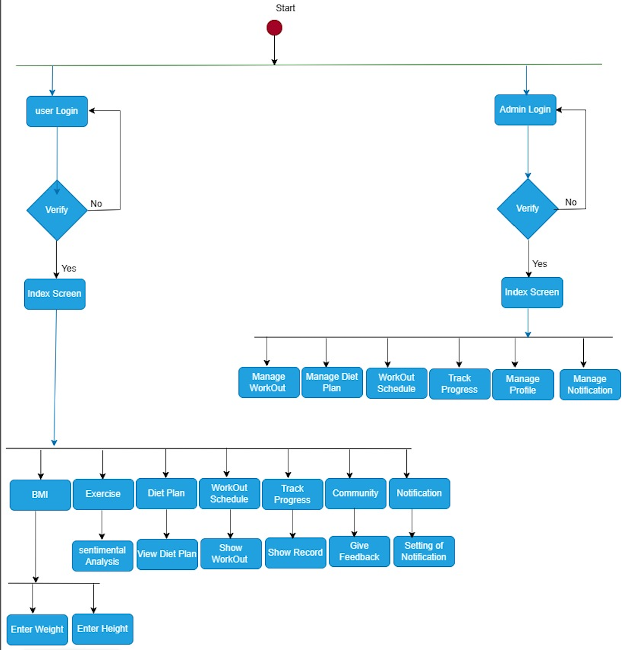

**Figure ‎4.3:- Methodology Diagram**

# Chapter 5

# Experimental Results and Analysis

* 1. **Endeavour (Team + Work + Way of Working)**
     1. **BodyBoost App**:

An app for workout and diet which uses sentimental analysis

* + 1. **Team Members**
* Anosh Junaid (ID: 11359)
* Muhammad Ali Hamza (ID: 12826)
* Hidayat Ullah (ID: 11939)
  + 1. **Work Breakdown Structure (WBS)**
       1. **Phase 1:** Application Front-End Development

**Task 1:**  Log in & sign-up page

**Subtask**: Storing user ID in Firebase Database

**Task 2:** Deployment of different pages of front-end

**Subtask**: Selecting an easy interface for user

**Subtask:** Storing Images in Firebase Database

* + - 1. **Phase 2:** Back-end sentimental analysis

**Task 3:** Integration with social media

**Subtask:** Applying Twitter API for user data

**Task 4:** Model Training for sentimental analysis

**Subtask:** Training Model with data set

**Subtask:** Google Colab integration for model enhancement

**Task 5:** Applying Roberta Pre-Trained model

**Subtask:** Collecting and analyzing data set

* + 1. **Project Schedule**
       1. **Milestone 1:** Application Front-End Development

**Start Date:** [1 Nov 2023]

**End Date:** [25 Dec 2023]

* + - 1. **Milestone 2:** Deployment of model for back-end

**Start Date:** [20 Nov 2023]

**End Date:** [27 Dec 2023]

* + 1. **Way of Working**
       1. **Agile Methodology**
* Overview of Agile Principles Applied
* Iterative Development Cycles
* Regular Team Reviews and Adjustments
* Sprint Durations, Planning Meetings, and Retrospective Sessions
  + - 1. **Collaboration Tools**

**Used Tools:** GitHub for Document and Data Sharing, Google Drive for Collaborative Document Editing

* + 1. **Risk Management**
       1. **Risk 1:** Technical Challenges

**Mitigation Plan:** Regular Team Training Sessions

**Contingency Measures:** External Expertise Consultation’

* + - 1. **Risk 2:** Resource Constraints

**Mitigation Plan:** Cross-training Team Members

**Contingency Measures:** Resource Reallocation

* + 1. **Additional Features:**
       1. Offline Alerts: Implementing offline alerts for immediate notifications to Trainee.
       2. Stakeholders**:** The primary focus is our End user(trainee), ensuring user-friendly features and effective solutions.
  1. **Flow Control/Pseudo codes**
     1. **Sign up Page**

Initialize controllers: username, email, phone, password display Sign Up Page ():

Show Screen with Logo, Username, Email, Phone, Password fields, and Sign Up button on Sign up Button Press ():

If validate Inputs (username, email, phone, and password):

Execute Sign Up (username, email, phone, and password) else:

Display Error Message ("Invalid inputs")

validate Inputs (username, email, phone, password):

Return true if inputs are valid, else false

execute Signup(username, email, phone, password):

create New User locally

send SignUp Request To Server

navigate To Homepage

display Error Message(message):

Show Error Message

create New User (username, email, phone, password):

// Local user creation logic

send Sign Up Request To Server(username, email, phone, password):

// Send user details to the server

navigate To Home Page():

Show Home Page

* + 1. **Login Page**

# Initialize user input controllers

Initialize controllers: username, password

# Display the login page display Login Page(): show Screen with: - Logo - Username input field - Password input field (masked)

- Login button

# Handle Login button press on Login Button Press():

if validate Inputs (username, password):execute Login (username, password) else: display Error Message("Invalid credentials. Please check and try again.")

Validate user inputs validate Inputs(username, password):

if any input is empty or invalid: return false else: return true

# Execute login logic Execute Login (username, password):

if authenticate User(username, password): navigate To Homepage()

else: display Error Message("Authentication failed. Please try again.")

# Authenticate user

authenticate User(username, password):

# Logic to check username and password against stored credentials or server

# Display error message

display Error Message (message):

show Error Message on Screen

# Navigate to the home page after successful login

navigate To Homepage():

show Home Page

* 1. **Components, Libraries, Web Services, and Stubs**
     1. **Components**
        1. **Naive bayes**

**Description:** For sentimental analysis

**Functionality:** Implements Naïve bayes for Mood detection of the user.

**Implementation:** Python

* + - 1. **Fine-tuned Roberto Model**

**Description:** For sentimental analysis

**Functionality:** Implements Roberto model for Mood detection of the user.

**Implementation:** Python

* + - 1. **Google Colab**

**Description**: Model training for Naïve bayes, fine-tune Robert0 model & tweeter integration.

Functionality: Jupyter Notebook Service Implementation: Python.

* + - 1. **Flutter Application**

**Description:** Front & Back-End of the Mobile application.

**Functionality:** Easily interface for user

**Implementation**: Flutter SDK.

* + 1. **Libraries**
       1. **Tweepy**

**Description:** Library to access Twitter API

**Integration**: integration with Roberto model

* + - 1. **Pandas**

**Description**: For data analyzing in Colab

**Integration:** Used for Model training in Naïve bye

* + - 1. **Sklearn**

**Description:** For features classification in Colab

**Integration:** Used for Model training in Naïve bye

* + - 1. **Flutter SDK**

**Description:** Cross-platform app development kit.

**Integration:** Utilized for Flutter app.

* + 1. **Web Services** 
       1. **Post man**

**Description:** It is an API platform for building and using APIs.

**Integration**: It is use to test different APIs. (See figure 5.1)

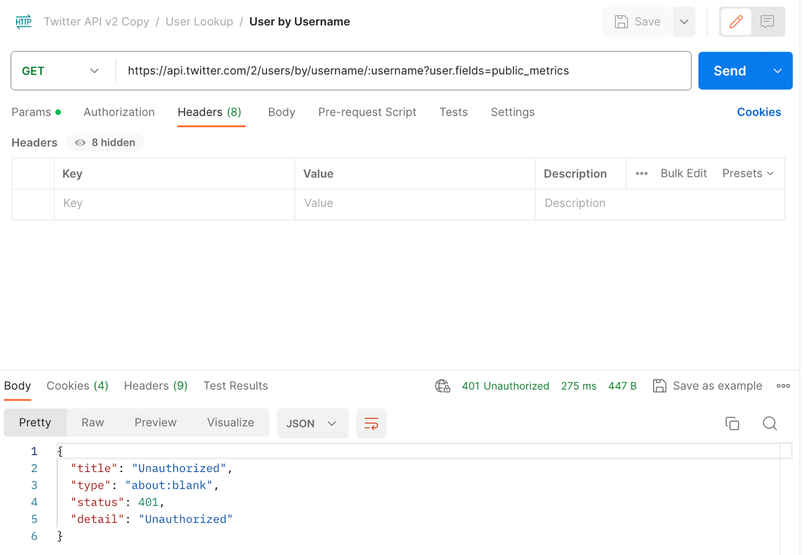

**Figure 5.1 Testing twitter API in Post Man**

* + - 1. **Scrapper API**

**Description:** It is use for web scrapping to get data

**Integration:** It is use to get the user data from social media through web. (See figure 5.2)

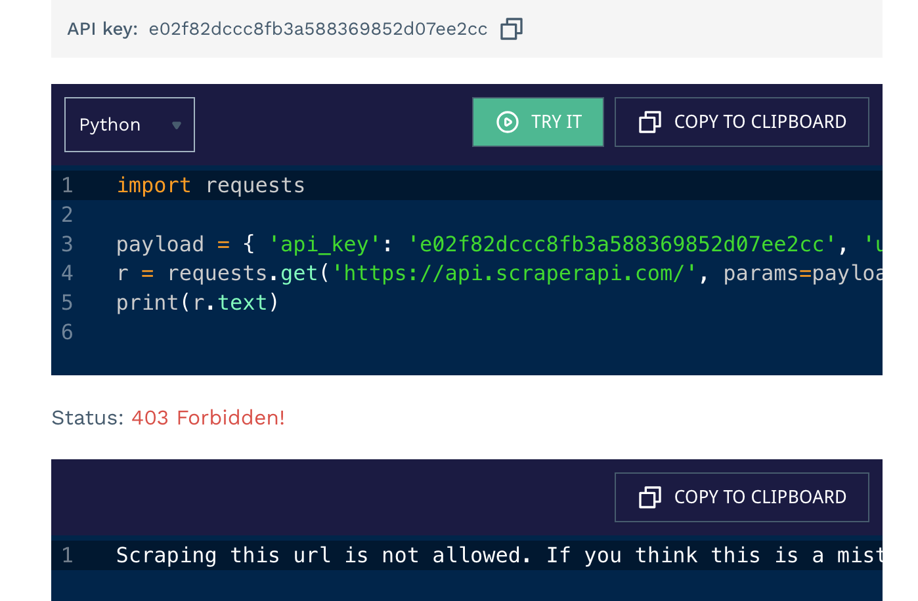

**Figure 5.2 shows that we are unable to enter twitter URL**

* + - 1. **Twitter API**

**Description**: For getting user data from in form of tweets

**Implementation**: implemented in Colab

* + - 1. **Firebase Database**

**Description:** Storing user ID

**Integration:** Utilizes Firebase.

* + 1. **Stubs**
       1. **Testing Stubs**

**Description:** Simulates external components for testing.

**Usage:** Validates component functionality.

* 1. **IDE, Tools and Technologies**
     1. **Optimized Technology Stack for Tomato Care Application**
     2. **Integrated Development Environment (IDE):**

**Backend:** Python (Specifically for Backend Development)

**Flutter**: Android studio Code

**Collaborative Model Training:** Google Colab

* + - 1. **Tools:**

**Version Control and Document Sharing**: GitHub

**Containerization:** Not Applicable (Omitted Docker for simplicity)

* + - 1. **Technologies:**

**Backend:** Python (Specifically for Backend Development)

**Framework:** Colab (Backend Web Framework)

**Machine Learning**: Transformers library, Auto Tokenizer

**Database**: Firebase

**Flutter:** Dart

* 1. **Best Practices and Coding Standards**
     1. **Software Engineering Practices**

**Version Control:** GitHub

Continuous Integration and Deployment Practices

* + 1. **Development Practices and Standards**

**Python Coding Standards:** Adherence to PEP 8

**Flutter:** Followed Flutter's Coding Standards

* 1. **Deployment Environment for Body Boost** 
     1. **Deployment Environment:**
        1. **Operating System:** Not Specified (Omitted AWS EC2

Instances for simplicity)

* + - 1. **Server Configuration:**

Not Specified (Omitted specific server configuration for simplicity)

* + - 1. **Database:**

Firebase

* 1. **Summary**

In this chapter, we outlined the composition of our project team, the detailed work breakdown structure for the implementation phase, and the methodologies and tools adopted for efficient collaboration. We addressed potential risks and mitigation strategies, presented flow control or pseudo codes, listed key components and technologies, and detailed the deployment environment. Our team adhered to best practices and coding standards throughout the implementation, ensuring a robust and effective solution.

Chapter 6

Conclusion and Future Directions

# Conclusion:

The goal was to develop a fitness app that works individually and more important see the mental health of other person. The mental state of a person is done by the Convolutional Neural Network(CNN) model. Dictionary was created to further preprocess the dataset. A Convolutional Neural Network (CNN) model was trained on the mental health where the textual data was fetch from tweeter samples, initially achieving an accuracy of 87%. However, by fine-tuning the model and incorporating weights from a Roberta model, the accuracy improved to 98%. Additionally, a functional frontend for the Fitness app, called "BodyBoost," was developed using Flutter. A MySQL database was built for the project. Then the focus shifted to developing a more robust model for detecting more information about the mental health of the person. A different machine learning model architecture called Roberta was trained using advanced techniques like transfer learning and fine-tuning, resulting in an accuracy of 93%. The development of the "BodyBoost" platform was completed with the same frontend and backend frameworks, along with the integration of the model. Version control systems such as GitHub were used for project development. The entire system, including the model and the fully functional platform, was successfully integrated and working together.

# Future Directions:

* 1. Increasing our dataset vocabulary and size, increasing the stop words dictionary by adding more vocabulary to it.
  2. Make a benchmark dataset for mood detection and publish it.
  3. Try transformers and explore more transfer learning techniques.

# Recommendations for future work:

If someone wants to work on this in future, then he/she can further improve the techniques we used and can enhance the overall performances we achieved. The use of different Transformers and advanced machine learning and feature engineering techniques can be used for the creation of robust prediction models. Fine tuning their respective model and increasing the vocab and size of the dataset can also help them achieve their benchmarks.

# Bibliography

[1] Facebook AL. (2019). RoBERTa and BERT. English. 160GB of text. SQuAD 94.6/89.4, 88.5 on the GLUE benchmark

[2] Basarslan, M. S., & Kayaalp, F. (2020). Sentiment analysis with machine learning methods on social media

[3] Gandhi, A., Adhvaryu, K., Poria, S., Cambria, E., & Hussain, A. (2023). Multimodal sentiment analysis: A systematic review of history, datasets, multimodal fusion methods, applications, challenges and future directions. Information Fusion, 91, 424-444.